Module 7: Aurora Assignment

Problem Statement: You work for XYZ Corporation. Their application requires a SQL service that can store data which can be retrieved if required. Implement a suitable RDS engine for the same.
While migrating, you are asked to perform the following tasks:
1. Create an AuroraDB Engine based RDS Database.
2. Create 2 Read Replicas in different availability zones for better infrastructure availability
Choose the AuroraDB Engine:
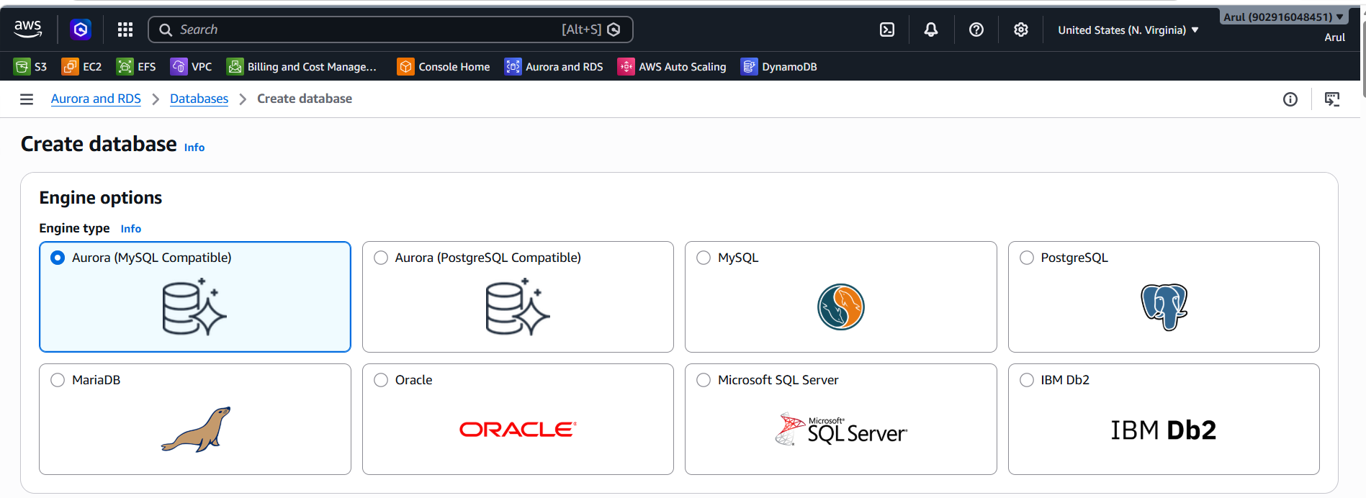
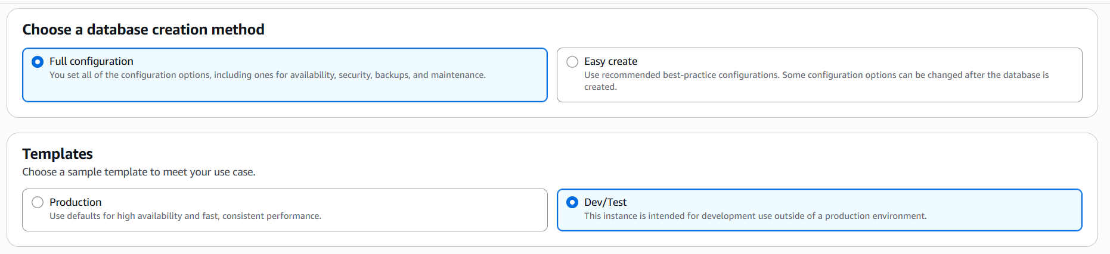
Choose the scalability type and ACU:
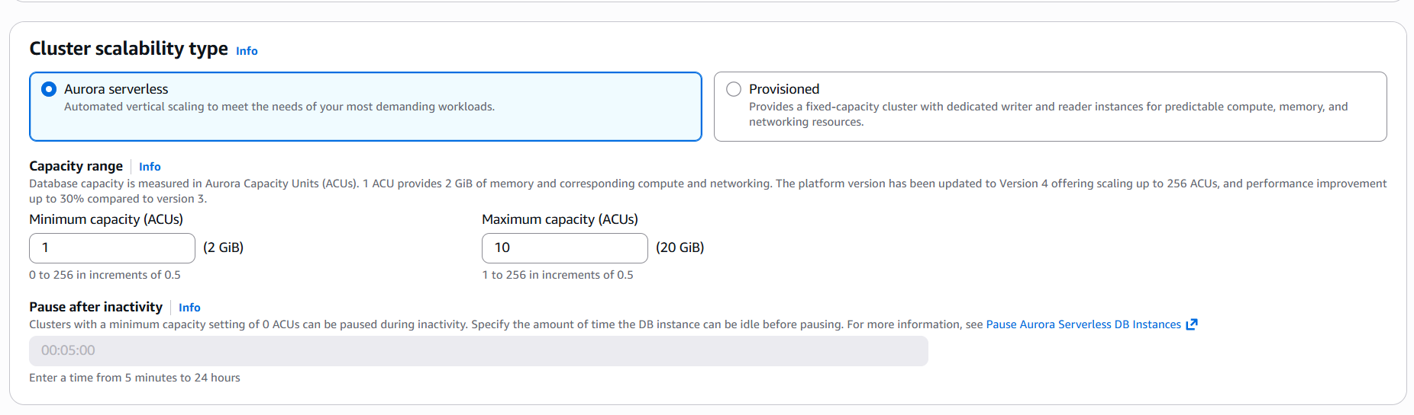

Mention the DB cluster name: student
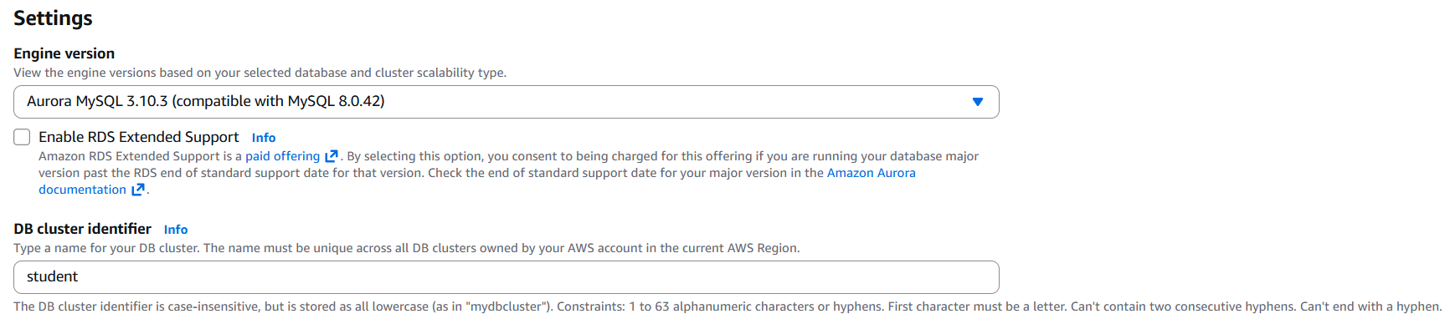
Credential setting: admin
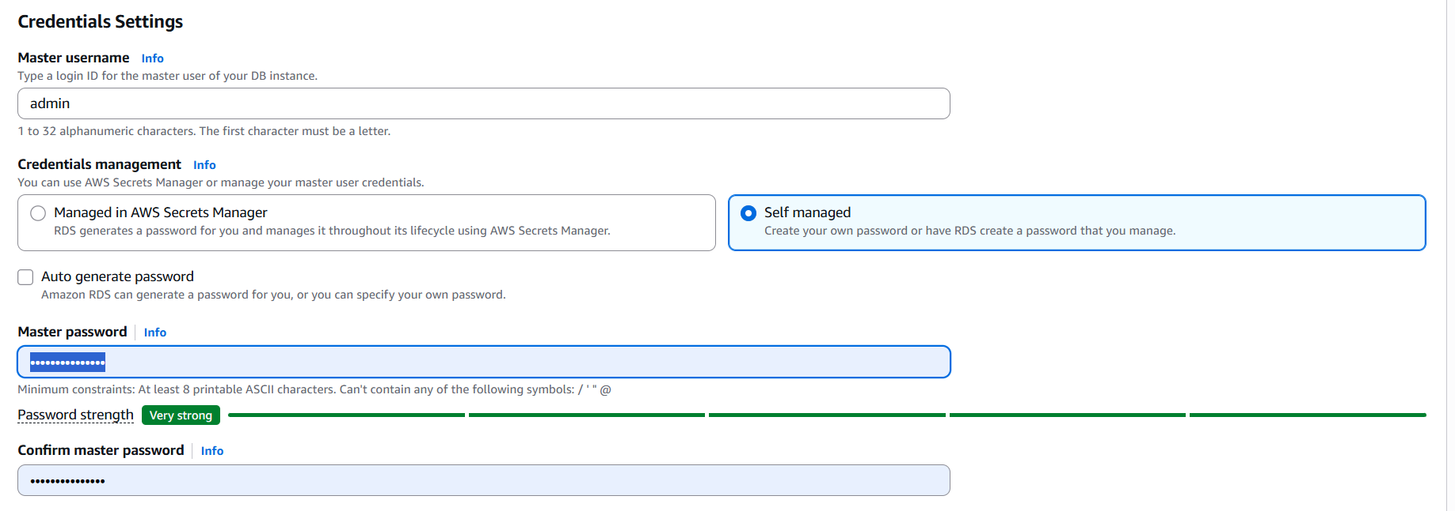
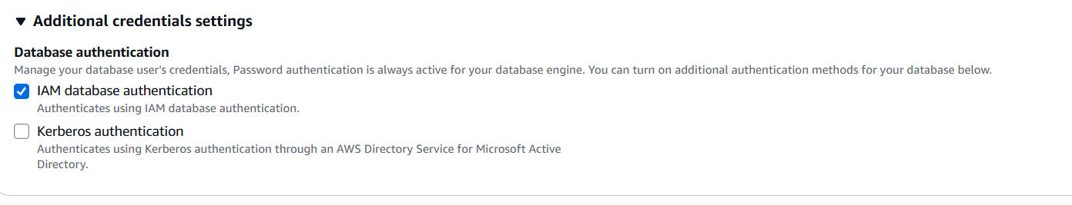
Storage configuration & Availability options: Will create the reader nodes later.
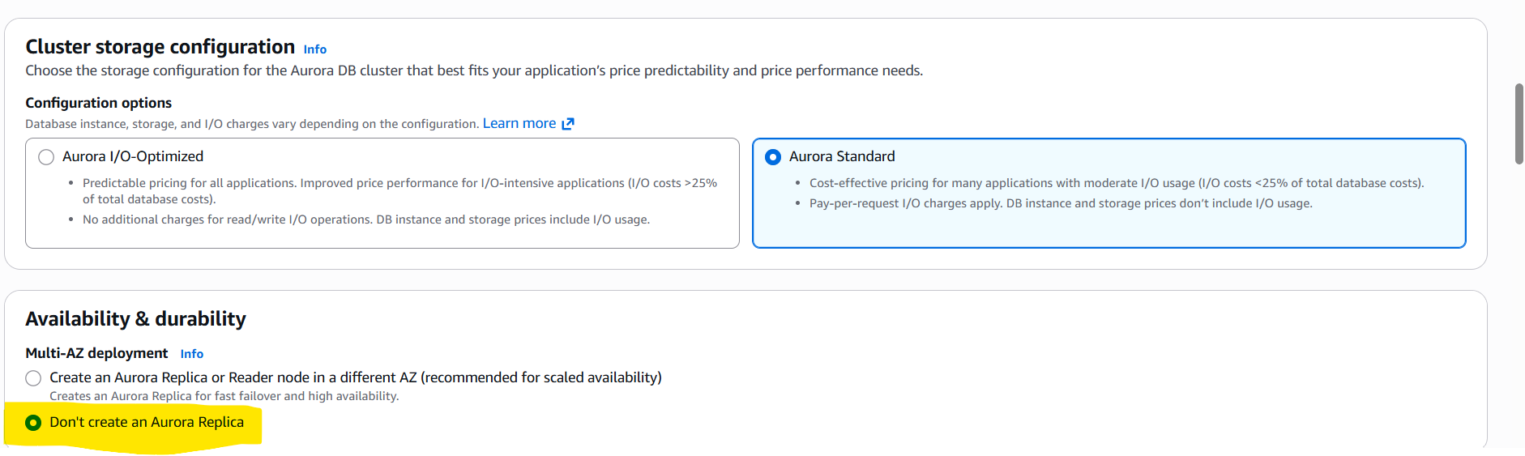
Network settings:
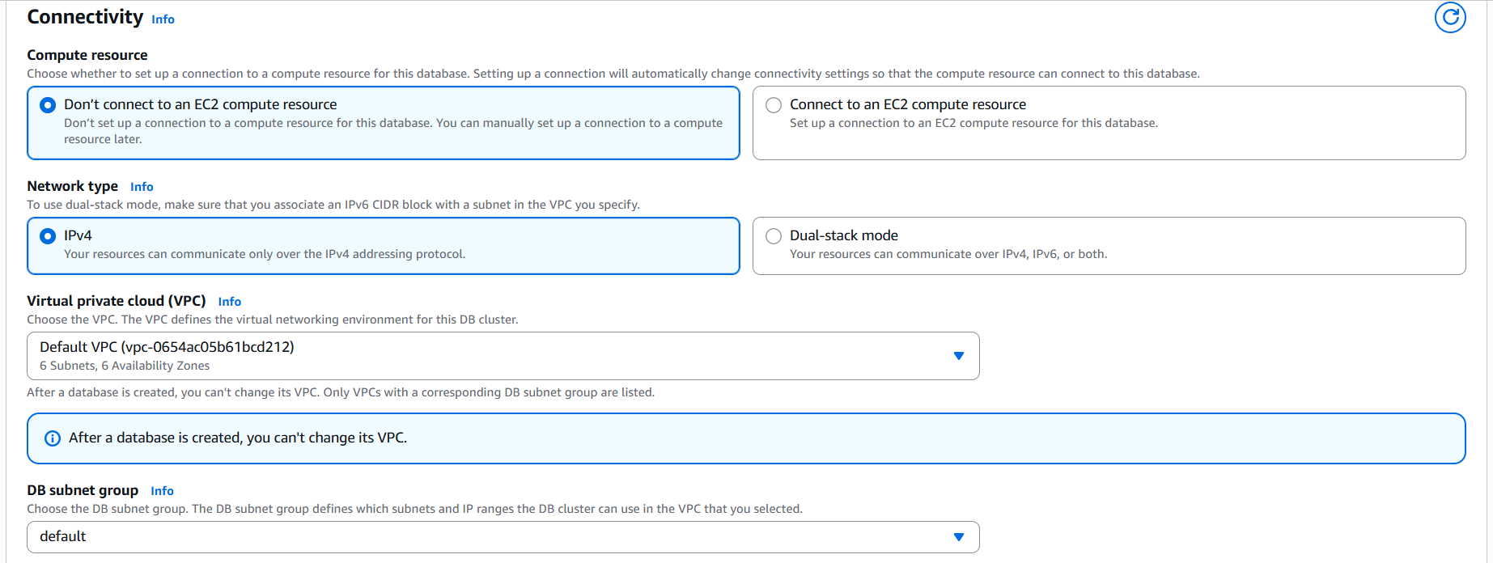

Enabling public access to connect with external resources:
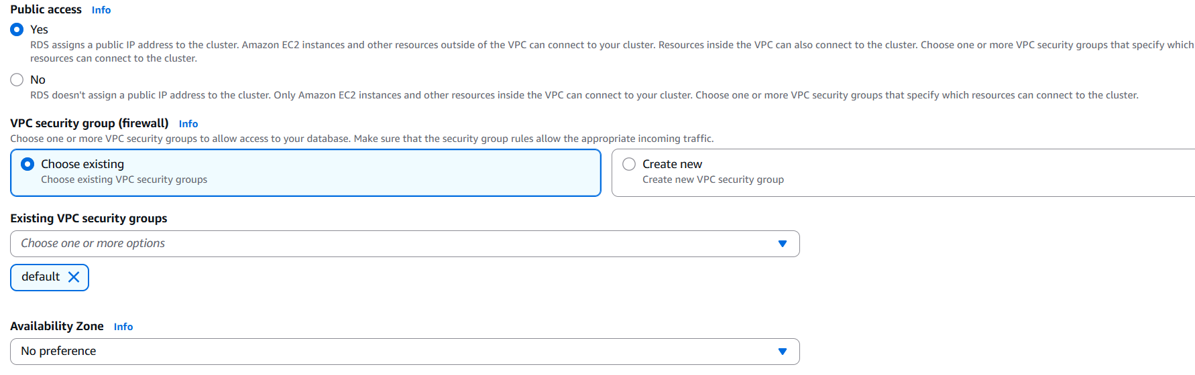
Monitoring methods:
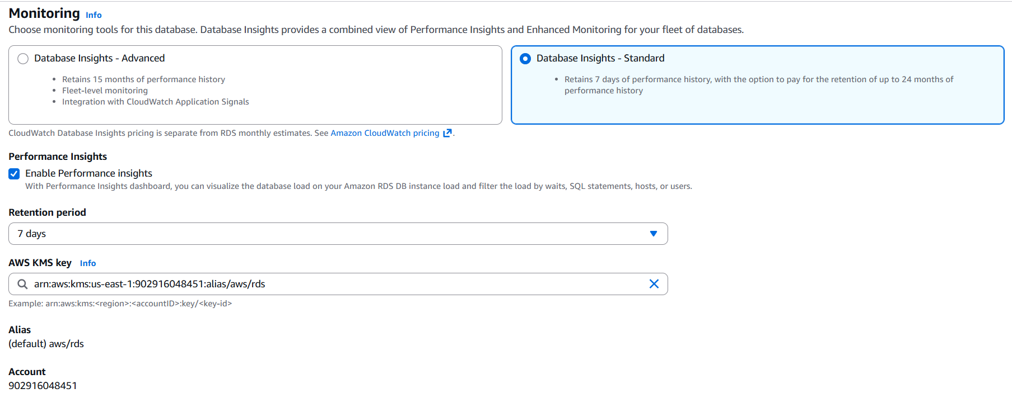
Additional settings:
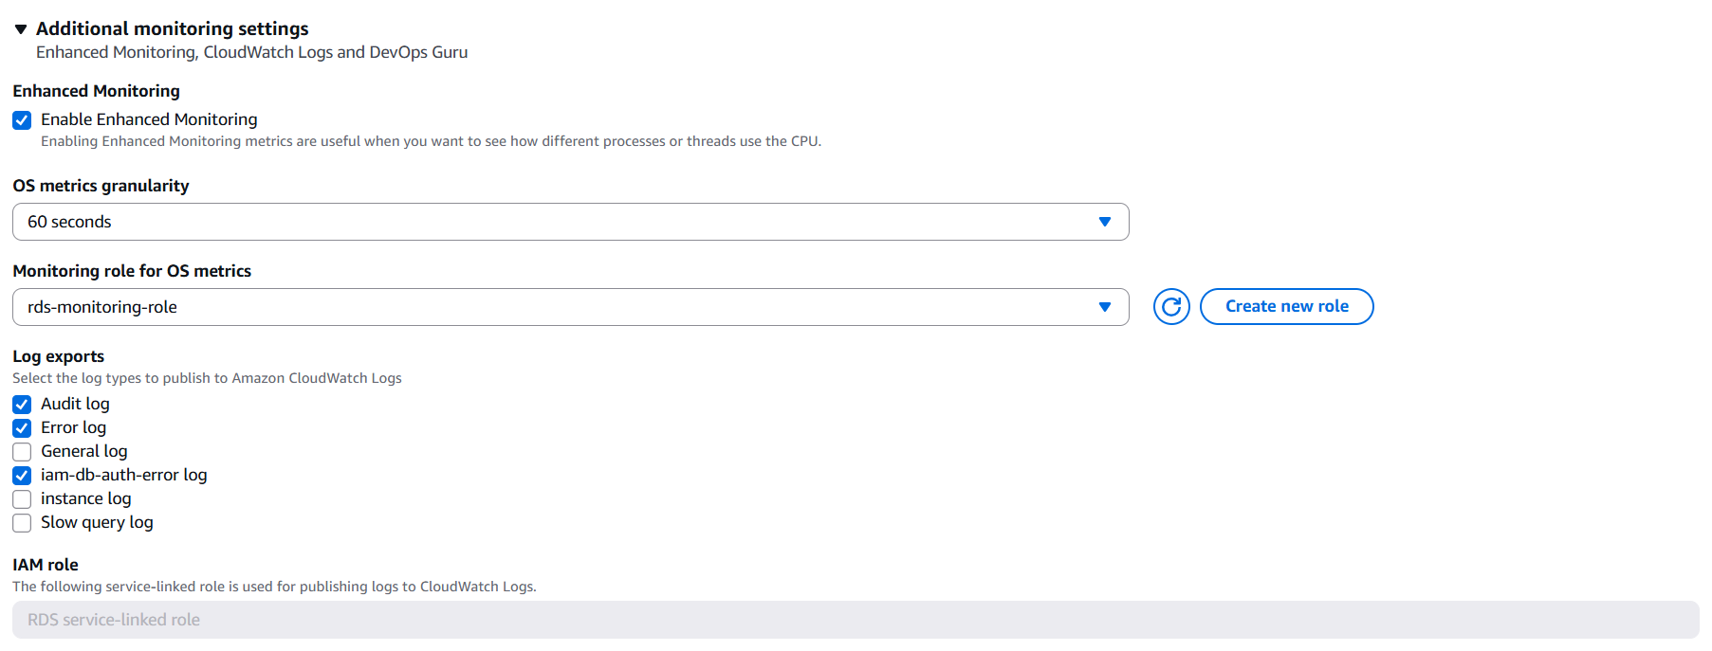
Created Cluster: student in us-east-1 and writer node: student-instance-1 in us-east-1c
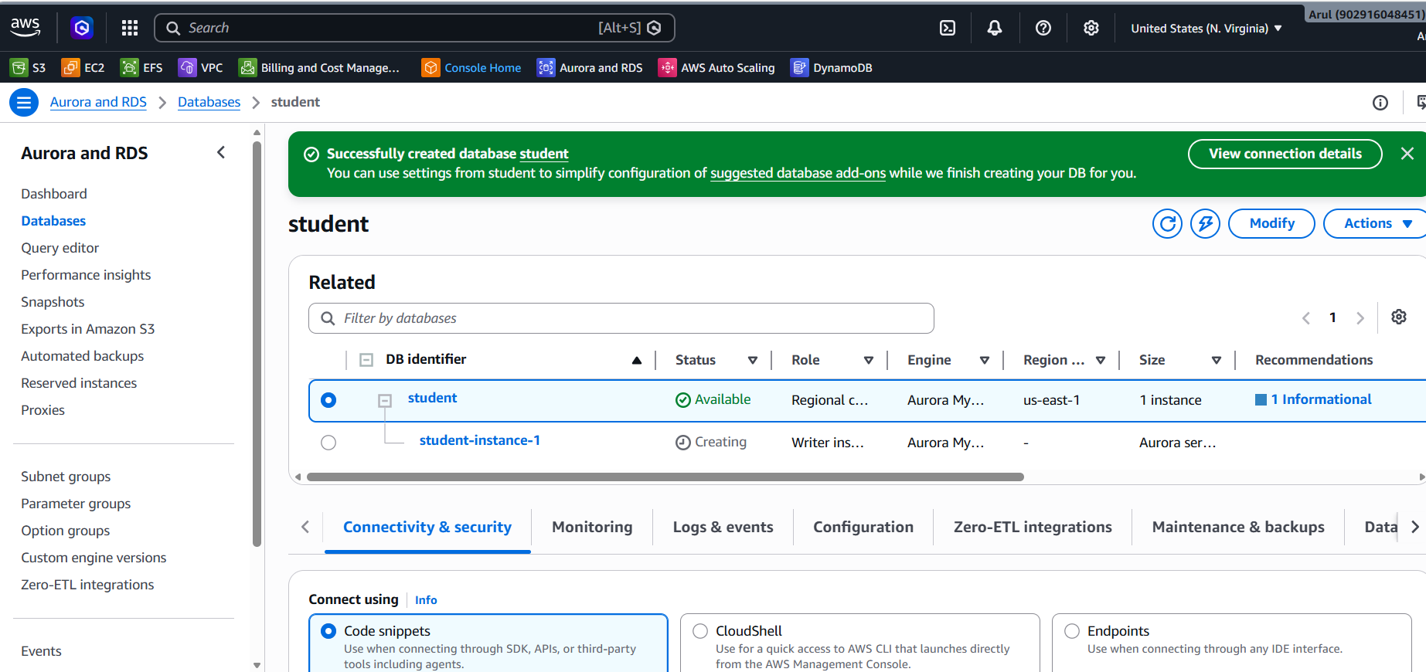
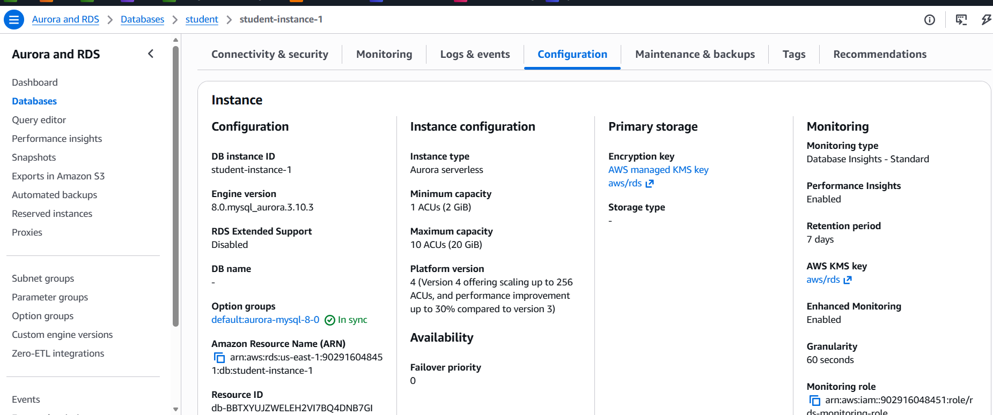
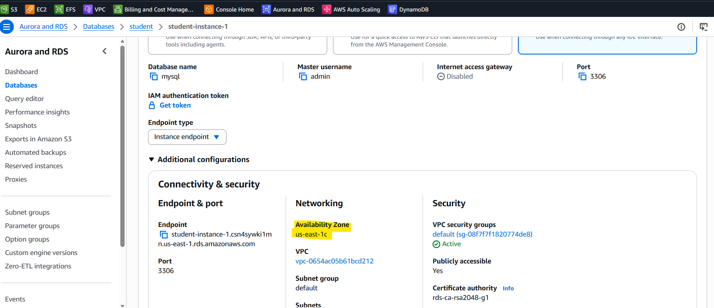

Creating the read replica: demo-rds-replica01 in us-east-1b
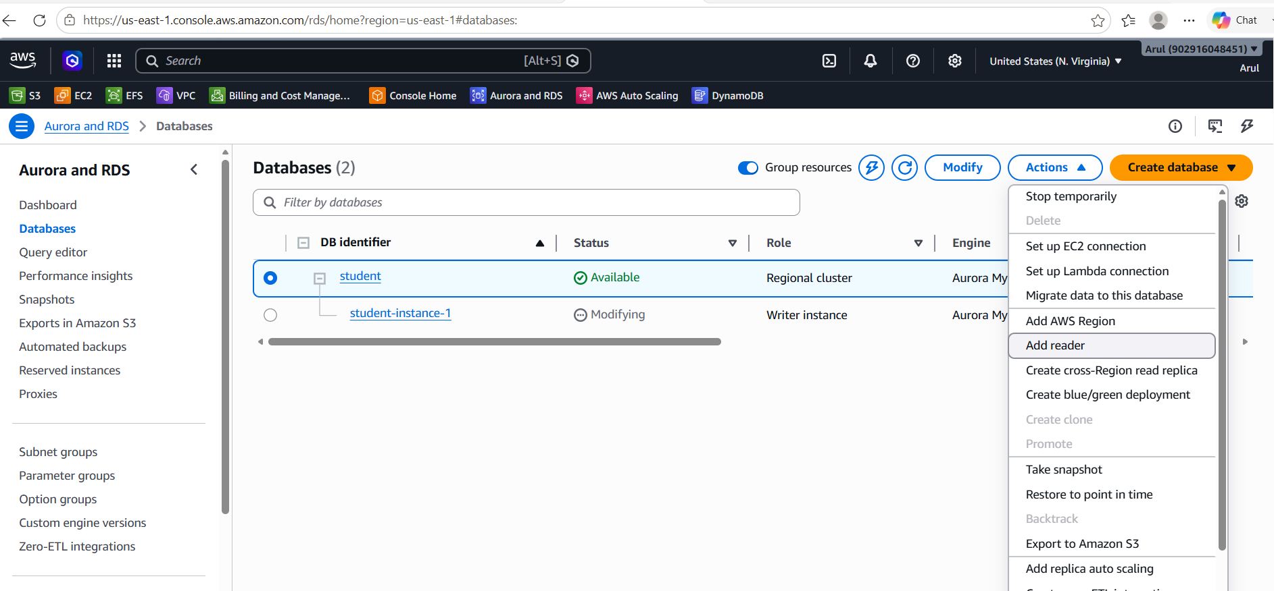
Name: demo-rds-replica01
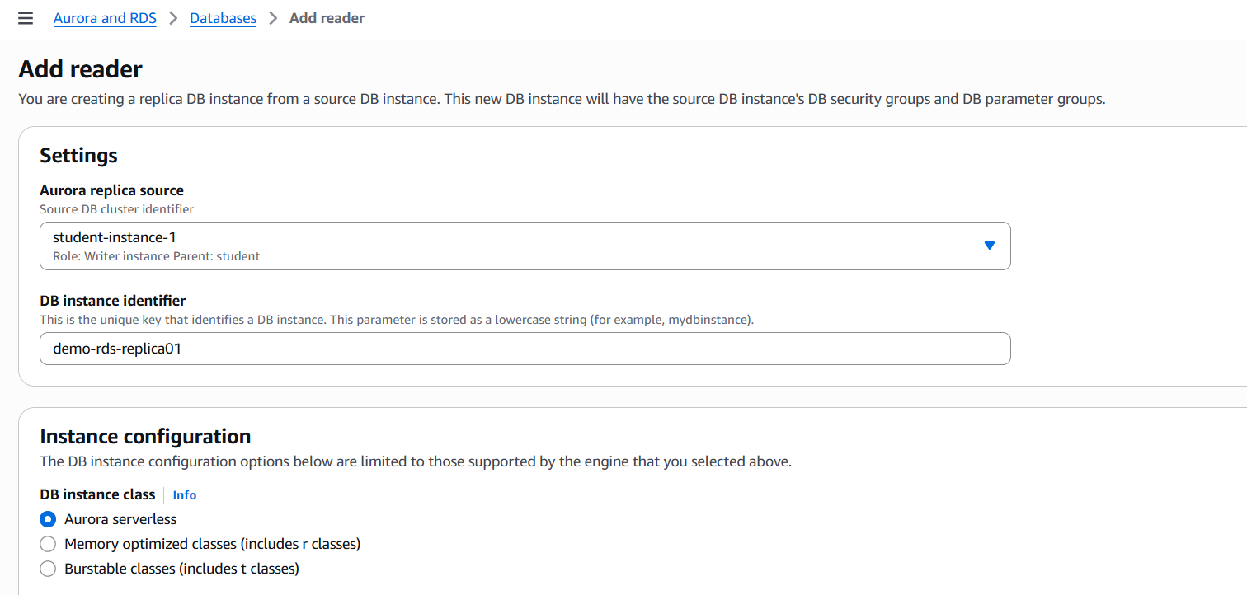

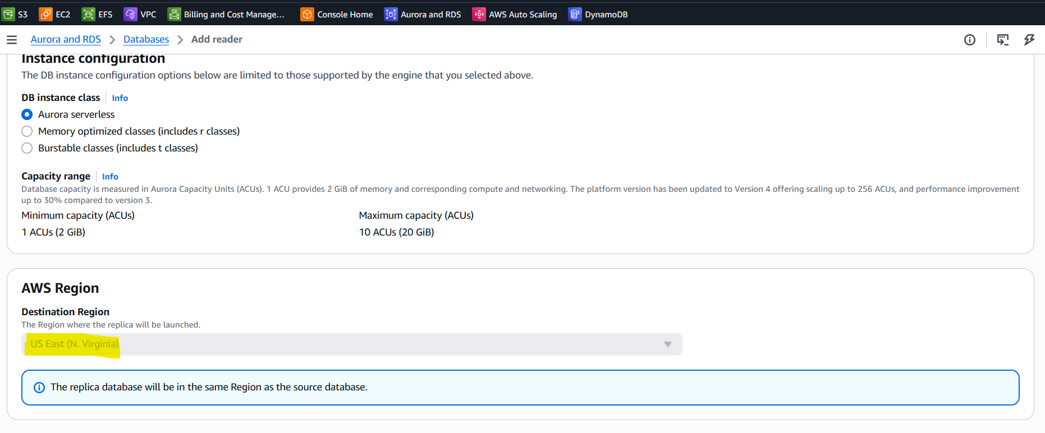
AZ: us-east-1b
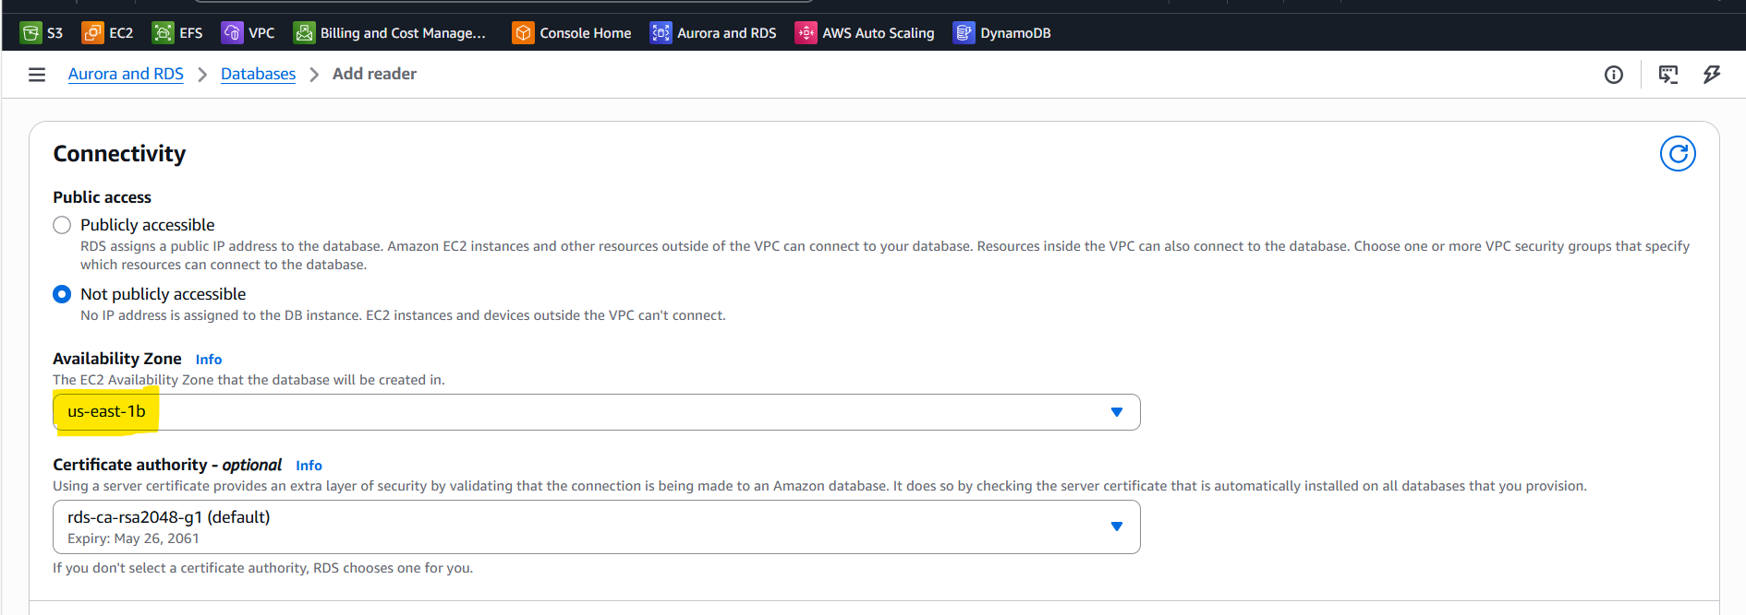
Other settings:
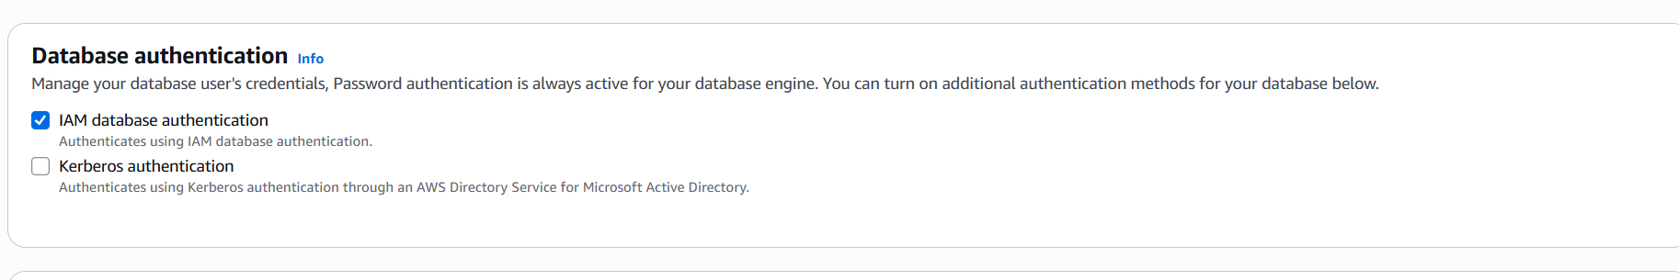
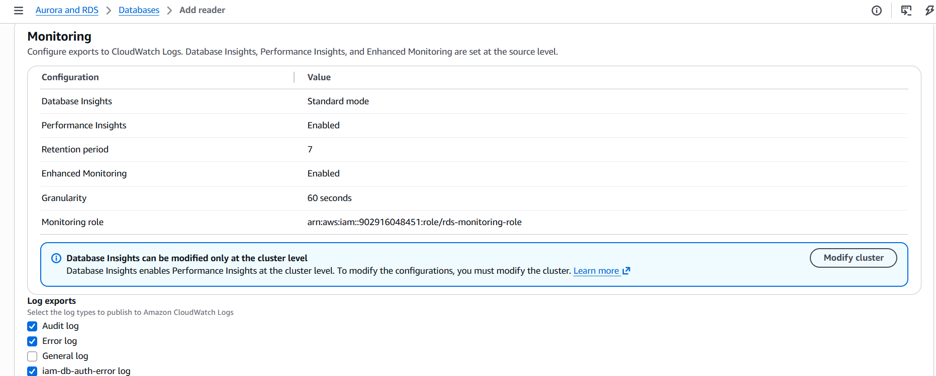

Failover priority:
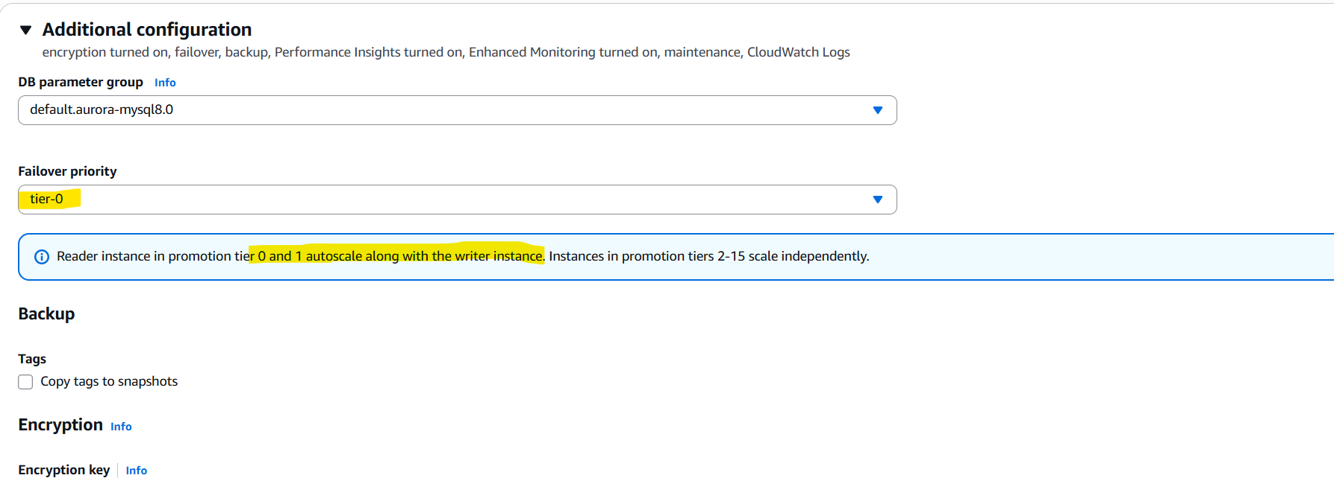
Reader demo-rds-replica01 is created:
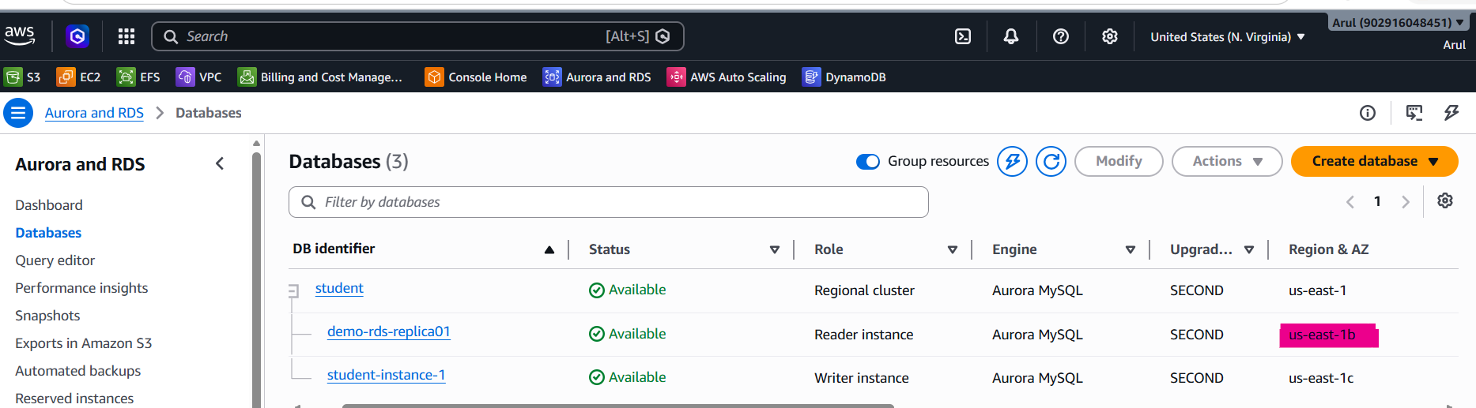

Creating another read replica: demo-rds-replica02 in us-east-1d
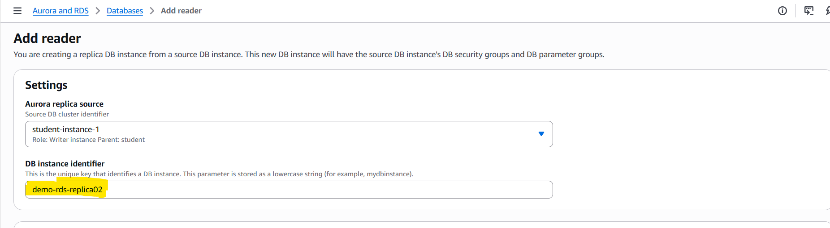
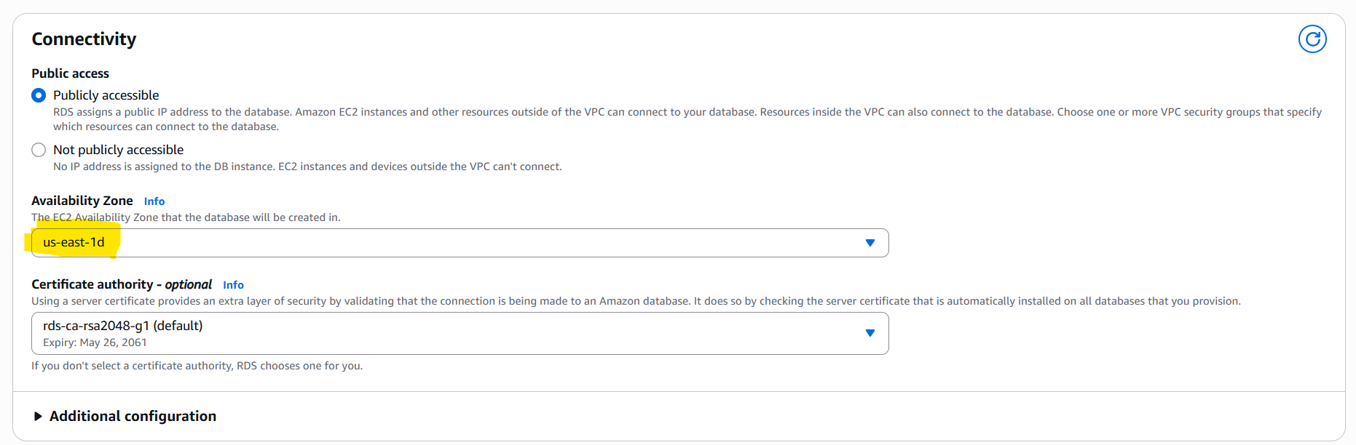

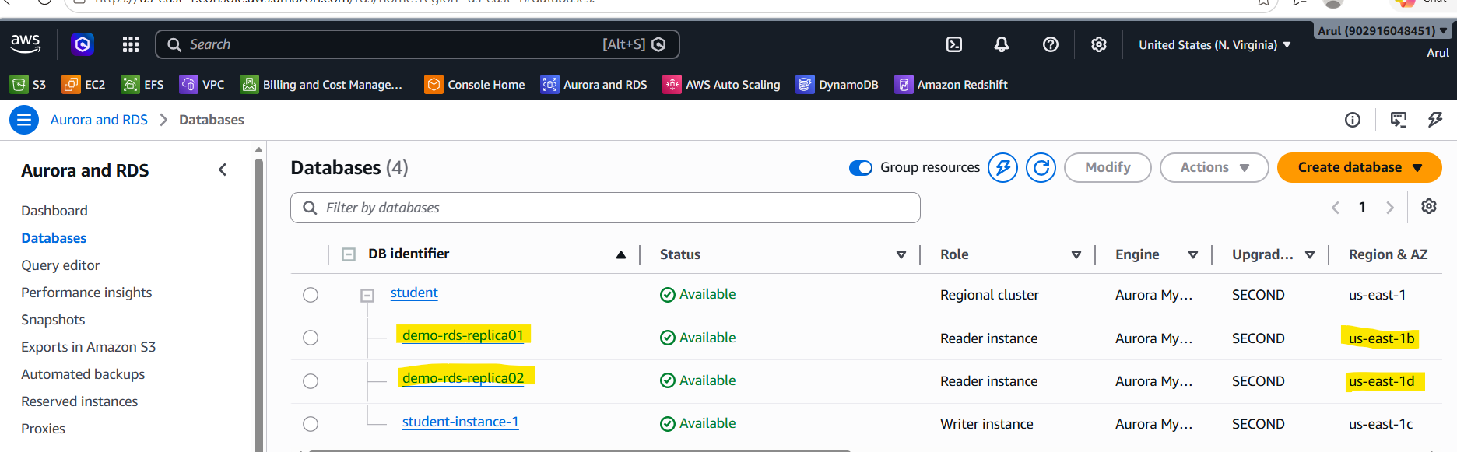

Connecting writer node with external mysql client:
student-instance-1.csn4sywki1mn.us-east-1.rds.amazonaws.com
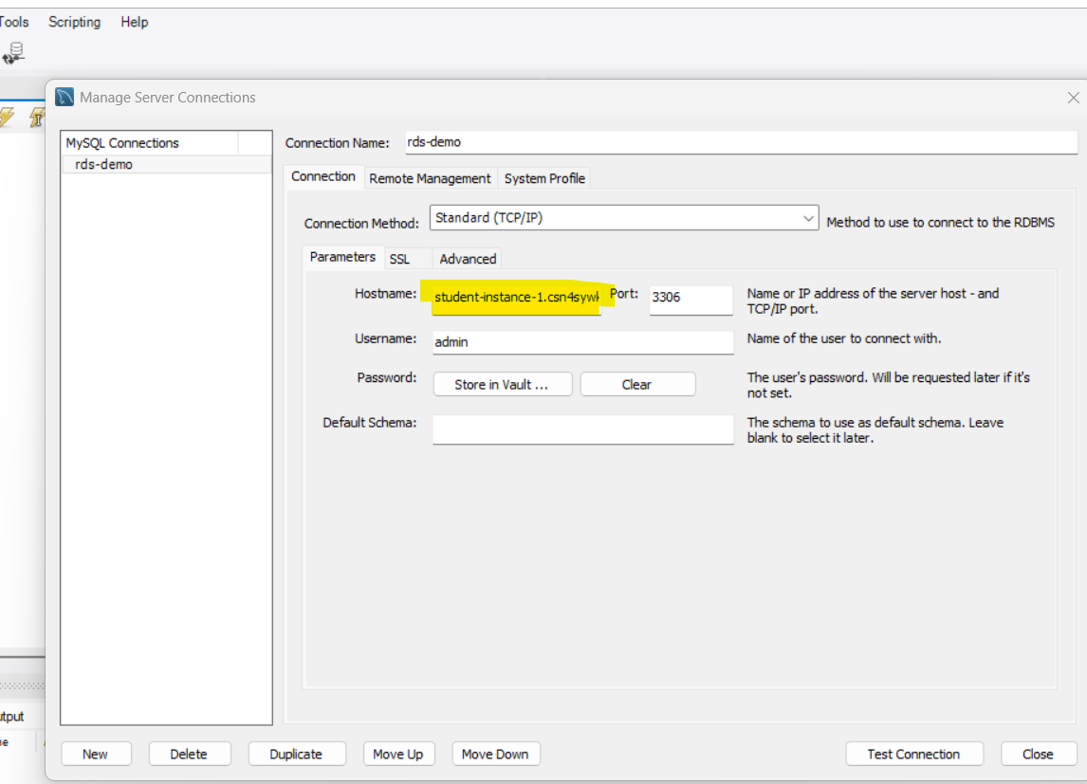
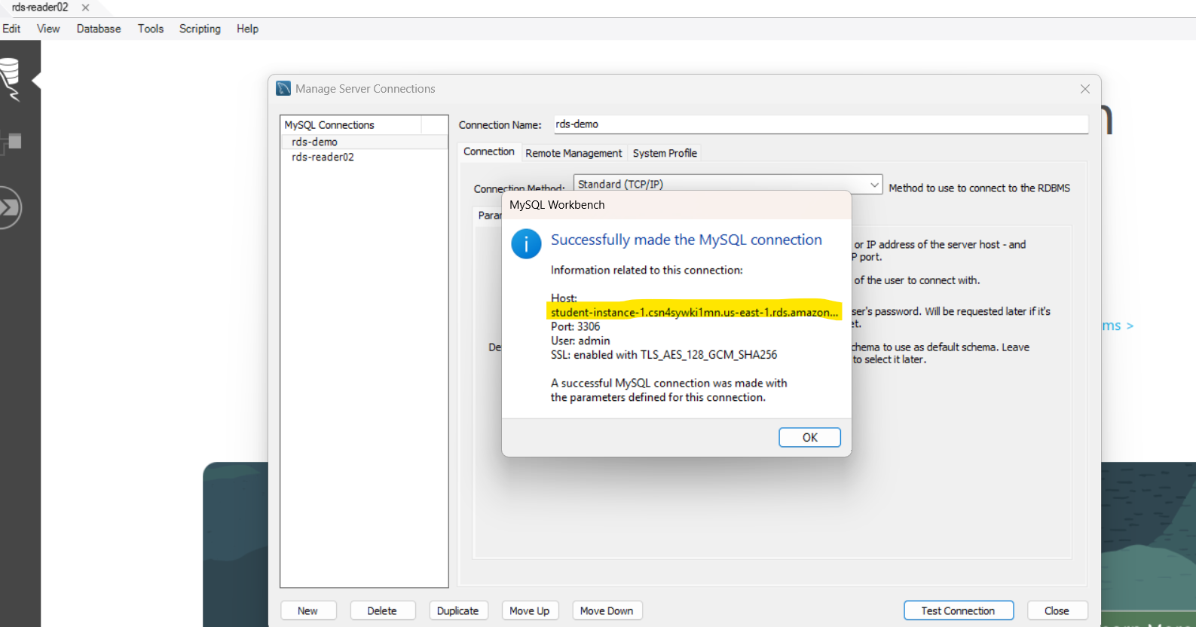
Create a Database on writer node:
CREATE DATABASE school;
USE school;
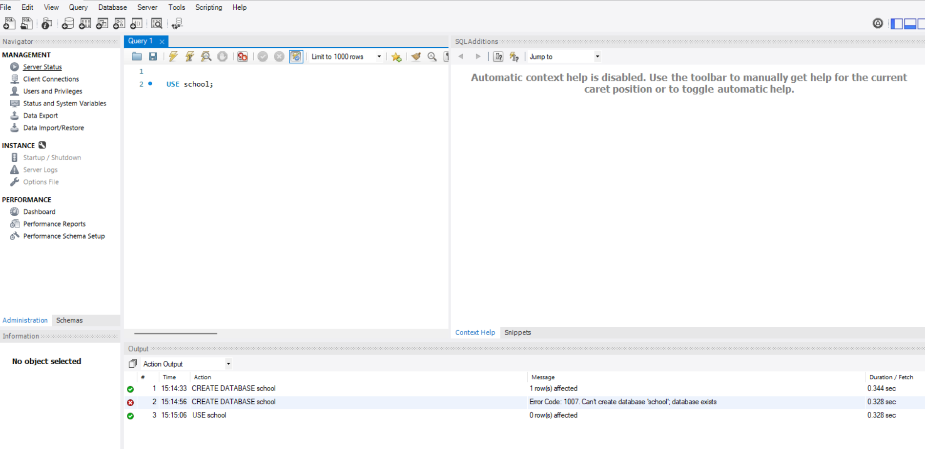
Create a Table: students on writer node
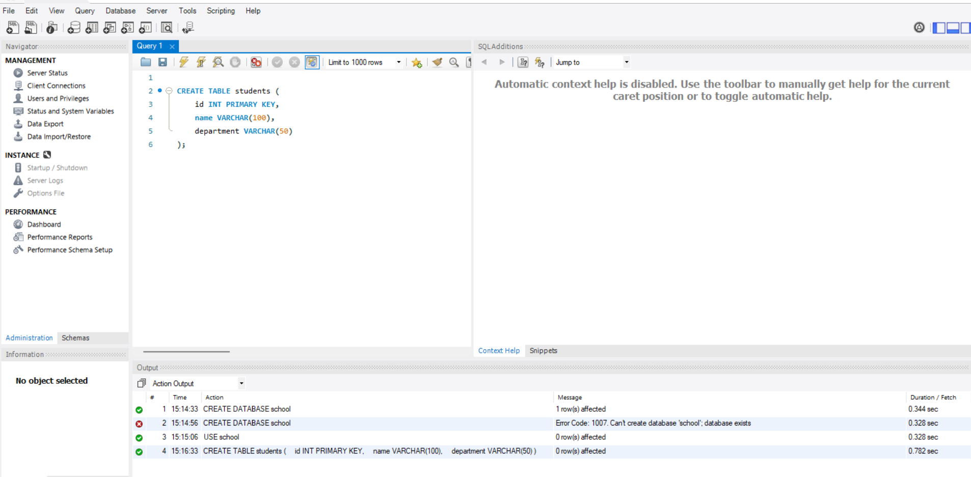
Insert Data to validate the writer node:
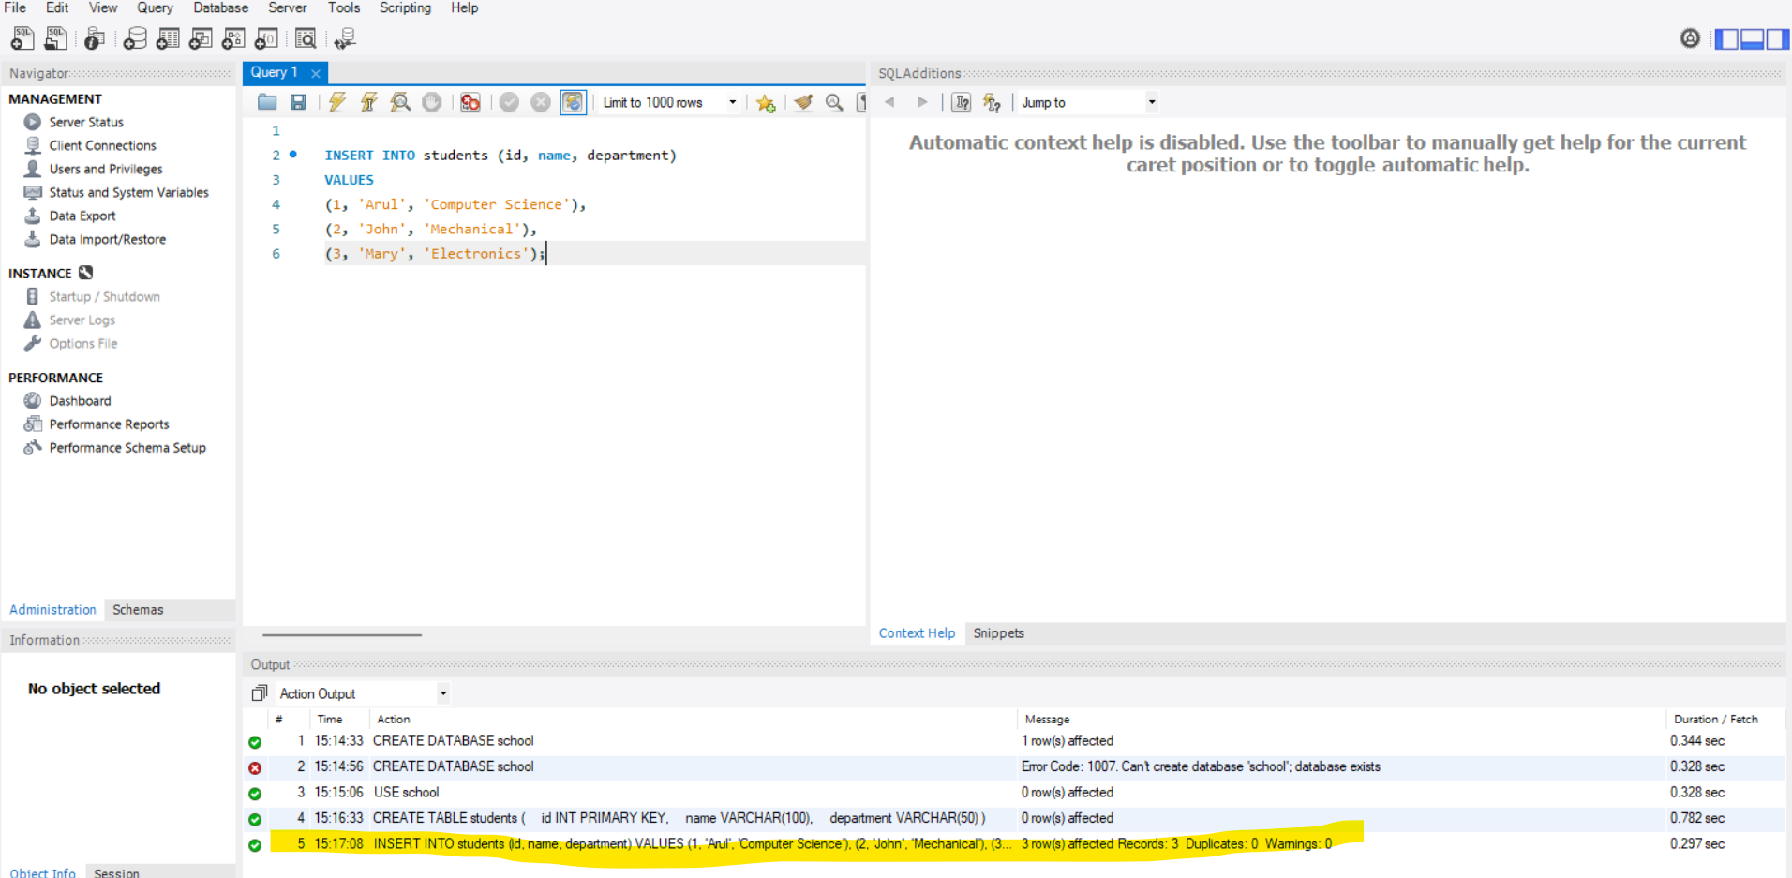
Querying the data on writer node:
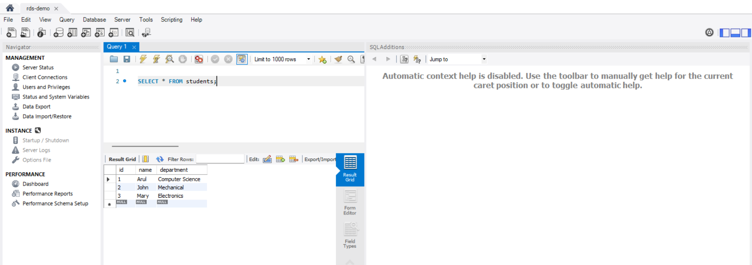
Connecting reader node with external mysql client:
demo-rds-replica02.csn4sywki1mn.us-east-1.rds.amazonaws.com
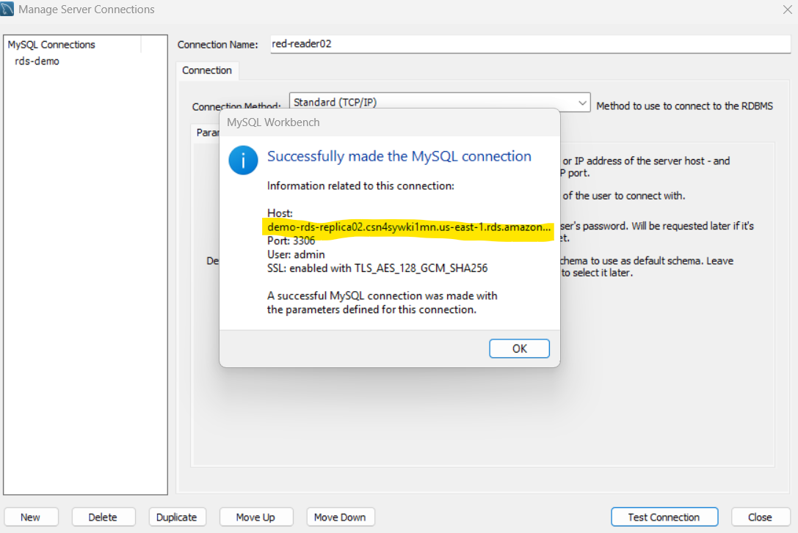
Querying the data on the reader node:
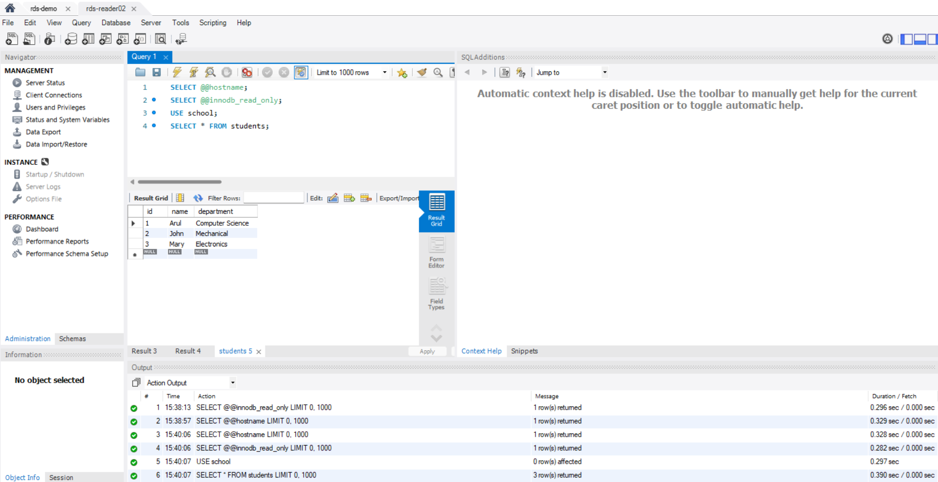

Trying to insert the data on the reader node:
Error code shows that running in read-only mode.
